**Day 1 - 14/5/2025**

**Barghavi Bethu   
112728766 – bethubal**

**SDLC**

**Task 1**

**What is SDLC?**

Software Development Life Cycle

Involves various stages of developing application involves various stages from planning to deploying and maintenance.

**Task 2**

**Why SDLC?**

Provide clear understanding in each and every stage of developing application to meet client needs

Also to check the desired outcome in each and every stage and to make necessary changes in early stages

**Task 3**

**What are the different steps of SDLC?**

1 Planning

2 Requirements

3 Programming

4 Developing

5 Testing

6 Deploying

7 Maintenance

**Task 4**

**What are the models of SDLC?**

1. **Waterfall Model**

In this model all the stages like planning, designing, developing, testing, deploying are performed one after the another. It is not suitable for larger projects. All the required information has to be predefined before designing stage.

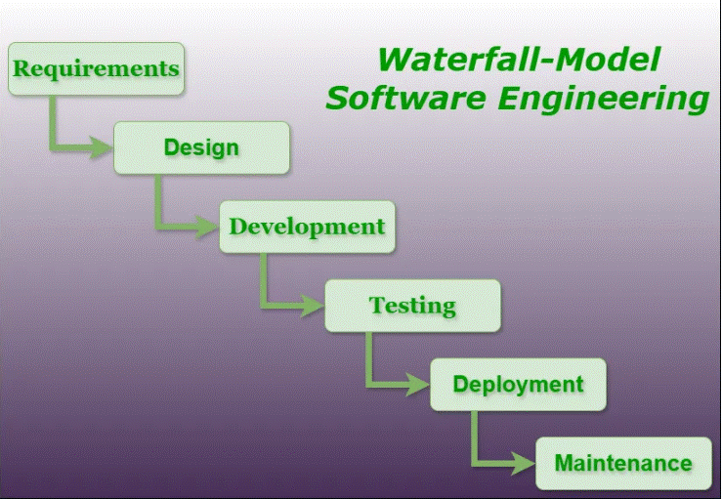

1. **Iteration Model**

Here all the stages are iterative and divided in to small parts, these parts can be easily tested. This can be used for larger and complex projects. Due to the iterations we will have the early error detection. This method will improve quality of project.

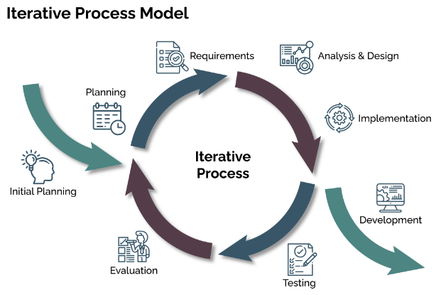

1. **V Model**

All the stages in this model is in V shape divided in to two half’s, the first half of V is verification and the second half is for validation. Verification happens in the development phase of the project and the validation is in the testing phase. Defects can be identified in early stages and easily fixed.

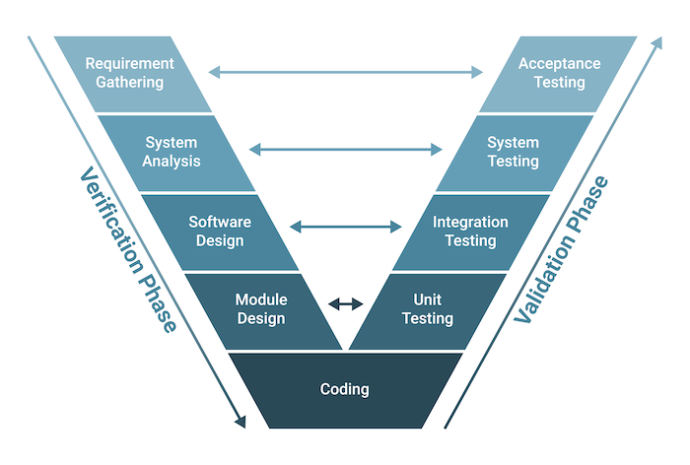

1. **Agile model**

Project will be divided as sprints and perform testing in each stages and discuss with clients to provide feedback and necessary changes. This can be used in complex projects as we will have early feedbacks. This method reduces risk as the complete project is divided into small cycles.

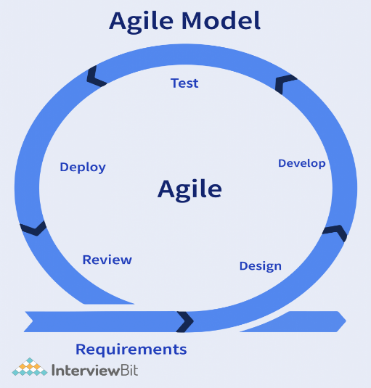

**Computer Networking**

**Task 5**

**1.what are the different network types?**

LAN - Local Area Network

WiFi

VPN - Virtual private Network

Cloud Network

WAN – Wide Area Network

**Task 6**

**What are the types of servers?**

1. Web Server

These are created to run websites and apps through web browsers, they are responsible for storing, processing of required information to users. HTTP is the example of web server.

1. Mail Server

This helps in storage, sending and management of emails. STMP – Simple Mail Transfer Protocol is used for emails.

1. Application Server

This helps to develop, process and run web-based applications, they usually use HTTP protocol and answer client requests.

1. Database server

This offers database services to client computers. User can access, modify, store and retrive date from database by executing query.

1. File server

This is a machine that provides shareable disks that can be accessed by work station on a network. This disk holds files of text, images, audio, videos etc.

1. Proxy server

This acts as medium between local and worldwide networks.

**Task 7**

This is Verbal task

What do you know about DNS? Domain Name System

**Task 8**

**What is TCP and UDP? What is the difference?**

**TCP- Transfer control Protocol**TCP creates communication line between sender and receiver for transmission of all data.

Data is secure while transferring.

This process is slower.

Data will be sent in a sequence.

**UDP – User datagram Protocol**

UDP does not create any connection between sender and receiver while transferring data.

There is a chance for losing data.

Faster data transfer.

Does not send data in a sequential order.

**Task-9**  
What do you know about MAC address? What is the difference between MAC address and IP address.

**MAC address –** Media Access Control Address

This is a 12-digit hexa-decimal code divided into 6 parts separated be (:) and each part has two digits. This is the physical address of a device. It is different for each device. This will be assigned during manufacturing. This is used by data link layer.

**IP address – Internet Protocol address**

This is a unique identifier by every system and that has internet connectivity. IP address is a global network. This is used to establish communication between different networks.

**Task – 10**

**What is OSI model?**

OSI - Open System Interconnections.

This model has 7 layers, it is easily understandable than TCP/IP model. Each layer has its own function. This describes the way how different systems communicates, or how data is exchanged between two devices.

1. **Physical layer** – This is a physical representation of devices, it transmits data over physical media.
2. **Data link layer** – Deals with errors on the physical layer. It has two sublayers called Media Access Control (MAC) and Logical Link Control (LLC)
3. **Network Layer** – This chooses router for destination
4. **Transport Layer** – Helps in transmitting data
5. **Session Layer** – Responsible for session establishment and termination
6. **Presentation layer** – Responsible for translation, encryption and data representation for the application layer.
7. **Application layer** – Application that user uses

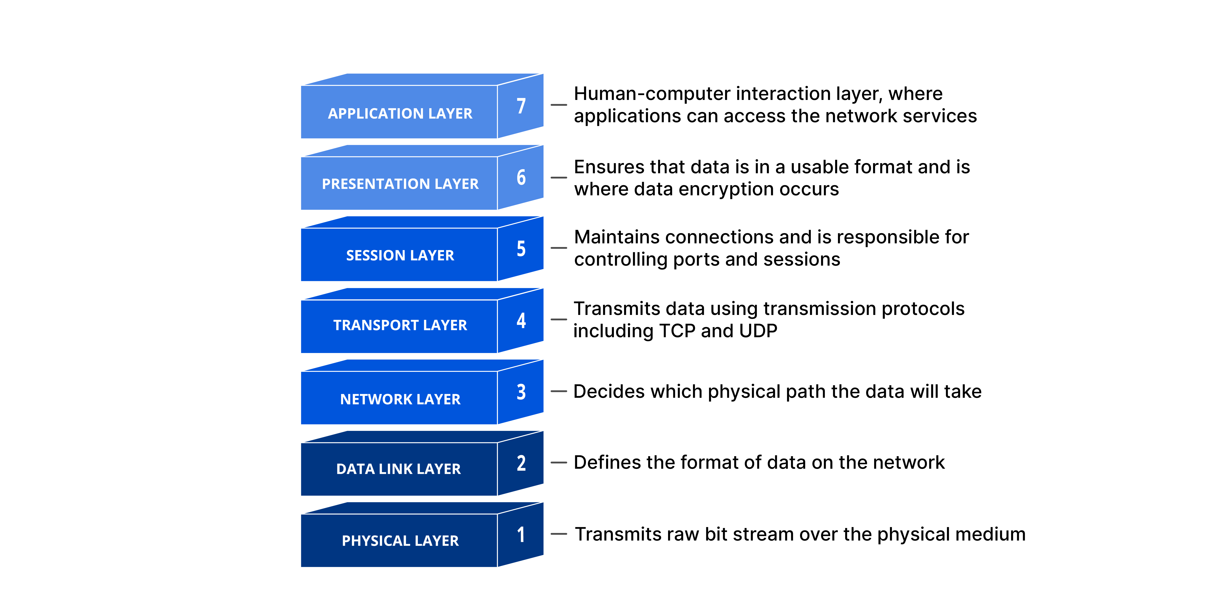

**Task -11**

**What is an IPv4 address? What are the different classes of IPv4?**

IPV4 means Internet Protocol version 4

These are 32bit numbers that are displayed in dotted decimal notations. A 32 but address contains two primary parts the network prefix and host number. All hosts with in a single network share the same network address.

IPv4 is divided into 5 classes A,B,C,D,E. Each class has a specific range of address from 1.0.0.0 to 255.255.255.255. A, B, C are the classes which are majorly used in internet.

**Task-12**

**What are the advantages of VPN?**

1. We can connect to remote servers so that we can use our local IP address from another location using VPN.
2. VPN enhances user privacy and security.
3. We can hide private information.

**Task -13**

**Types of VPN - Give 1 liner for each**

1. Access VPN – We can remotely connect to private network using Access VPN.
2. Site to site VPN – This helps to provide connectivity between one network to another network over internet.
3. Intranet VPN – This provided site to site internal connectivity with in the organization.
4. Extranet VPN – Used to connect a particular organizations network from outside of organization.

**Task-14**

**Node and link**

Node are the end points or the devices which are in the network and link is the connection between the nodes.

**Task -15**

**What is Topology**

Topology is an arrangement o representation on nodes or devices which are connected in a computer network.

**Task -16**

**What are the different types of network Topology?**

1. BUS Topology – All the devices share a single communication line. Data travels in both directions along cable.

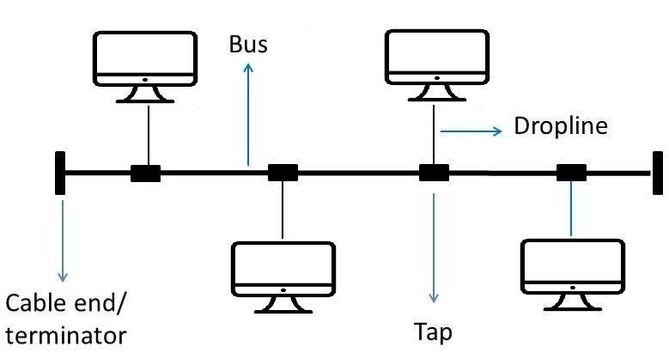

2. Star Topology - All the devices are connected to central hub or switch. If the central hub fails then whole network fails.

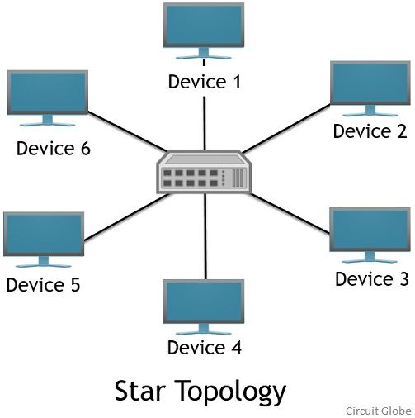

3. Ring Topology – All the devices are connected in a circular loop. Each device works in a loop if once device fails it will affect the entire network.

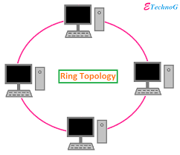

4. Tree Topology – This is the combination of star and bus topologies.

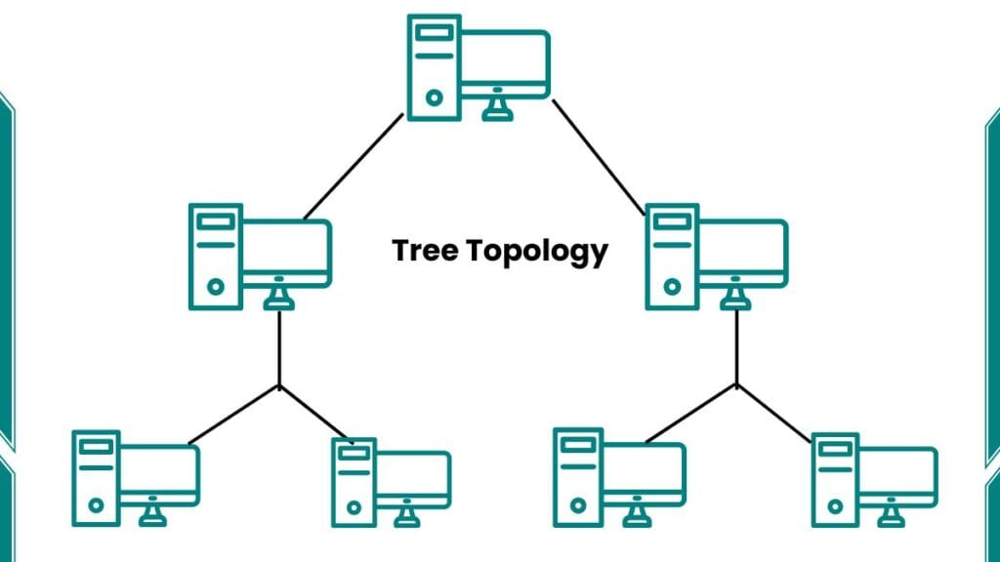

5. Mesh Topology – In this each and every device in the network is connected to each and every device.

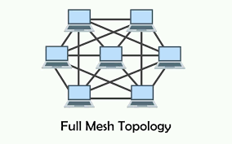

**Task -17**

**What is extended bus topology?**

It is Tree topology.

**Task-18**

**What is the use of router and how it is different from gateway?**

Router – This connects multiple networks and directs data between the devices. Commonly used routers are the once which we use in houses for WiFi connectivity.

GateWay - This is a translator between two different network systems. Conncets network using different protocols. Converts data formats, protocols or network so that different systems can communicate.

**Task 19**

**Explain SMTP Protocol with diagram**

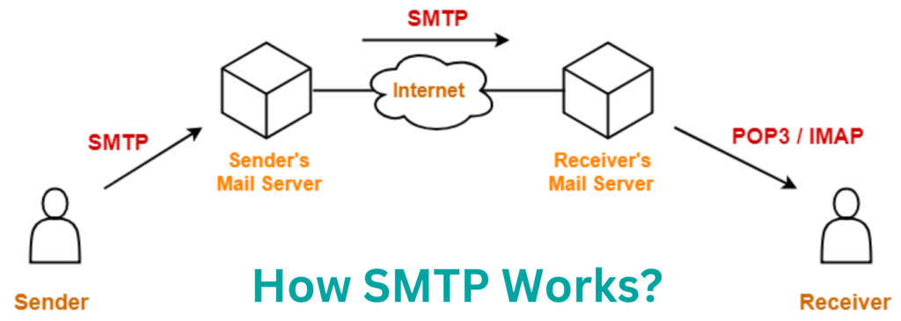

**Task – 20**

**Difference between OSI and TCP/IP**

TCP/IP –

* Transmission Control Protocol/Internet Protocol
* 4 Layers
* This will have Application, Transport, Internet, Network Access layers.
* This is a practical model mostly used in real networks.
* Error handling in mostly done in the transport layer
* Delivery of package is not guaranteed in TCP/IP model.

OSI –

* Open Systems Interconnection
* 7 Layers
* This will have Application, Presentation, Session, Transportation, Network, Data link, Physical layers.
* Theoretical model mostly used in education purpose.
* Error checking is done in both transport and data link layers.
* Delivery of package is guaranteed in OSI model.

**Task – 21**

**What is HTTP and HTTPS?**

HTTP - Hypertext Transfer Protocol.

HTTPS - Hypertext Transfer Protocol Secure.

**Task - 22**

**What is LLD and HLD in SDLC?**

**LLD –** Low level Design is a detailed description of every module of software, it involved designing classes, methods, interfaces and interactions between them ensuring that code is efficient and maintainable.

**HLD –** High Level Design generally refers to the overall design of a system and describes the overall architecture/description of any project. This includes design features and whole architecture of the project.

**Task 23**

**What is SRS?**

SRS means Software Requirement Specifications. This is a detailed document created during the requirements phase of SDLC. This will helps in understanding what the document will do and how it is expected to perform. It minimizes the developers time and effort required to achieve desired goals.

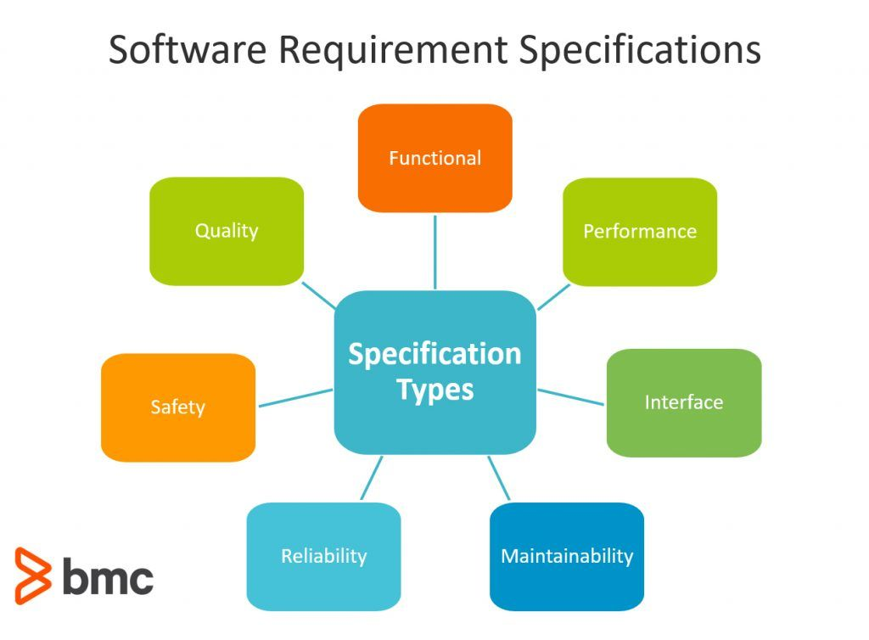

**SDLC MCQ**

1. A feasibility study using the SDLC model is conducted to

determine whether or not the project is technically possible

determine whether the proposal is financially viable

Both a and b

None of the above

1. A well-documented life cycle model aids in the detection of what during the development phase?

Inconsistencies

Redundancies

Omission

All of the above

1. How many lines of code does the Build & Fix Model suit for programming exercises?

100-200

300-400

600-700

Above 800+

1. In which life cycle does regression testing play a significant role?

Waterfall model

V model

Iterative model

All of the above

1. What determines if the project should go forward?

feasibility assessment

opportunity identification

system evaluation

program specification

1. What is the most significant disadvantage of employing the RAD Model?

Developers/designers that are highly **specialized** and skilled are required.

Component reusability is improved.

Encourages client/customer input.

Increases component reusability.

1. Which of the following developmental models is incremental?

Prototyping, V model, Agile

Prototyping, RAD, Agile, RUP

Prototyping, V model, RAD, Agile, RUP

All of the above

1. Which of the following is an Agile development characteristic?

Shared code ownership

Test-Driven Development

Implement the simplest solution to meet today's problem

Continual feedback from customer

All of the above

1. Which of the following steps in the SDLC framework are valid?

Requirement Gathering

Software Design

System Analysis

All of the above

1. Who is in charge of system development, staffing, budgeting, and reporting, as well as ensuring that deadlines are met?

Project managers

Network engineers

Graphic designers

Systems analysts